Reserving Cisco Smart Licenses for “Offline” Networking Devices

*A Step-by-Step Guide written by Luke Snell*

|  |
| --- |
| Licensing and Right to Use Information |
| **Do not remove this section without the written permission of the author.**  This document is licensed under the Creative Commons Attribution Share Alike 4.0 International licence. You may freely use, modify and share this document provided that it is not resold for commercial gain. If you would like to rebrand and/or sell this document commercially then an exception request must be submitted and authorised (potentially requiring payment) from the author Luke Snell via [admin@ether-net.com](mailto:admin@ether-net.com),  Cisco Systems Inc and/or its affiliates are permitted to utilise this document commercially without any requirement for an exception request. |

|  |  |
| --- | --- |
| Document Information | |
| **Document Title** | Reserving Cisco Smart Licenses for “Offline” Networking Devices |
| **Brief Description** | This document details how to use Cisco’s smart license reservation system to license devices that cannot / do not possess Internet connectivity. |
| **Create Date** | 08.02.21 |
| **Author** | Luke Snell |
| **Version** | 1.0 |

|  |  |  |  |
| --- | --- | --- | --- |
| Revision History | | | |
| **Date** | **Version** | **Revised by** | **Revision Notes** |
| 14.01.21 | 1.0 | Luke Snell | Initial Public Release |

**Disclaimer**

**Please read this section carefully prior to utilising this document.**

This document is an unofficial resource that has been created to detail how a network administrator can license, and manage the licensing of, Cisco networking equipment that cannot connect to the Internet.

The author uses a specific example with Cisco Catalyst 9000 series switches that utilise Cisco IOS-XE. This guide may may not be suitable for alternate equipment.

The author recommends consulting your official Cisco Partner or Cisco Account Manager for specific licensing enquiries or raising a support case through Support Case Manager for specific licensing issues.

By continuing with this document, you automatically acknowledge that ether-net and its author(s) are not responsible for any damages that may arise within your technical environment which may result from the indirect or direct usage of this guide. You also acknowledge that no support or warranties are extended by ether-net should you utilise this document.

# Table of Contents

Disclaimer 3

Pre-Requisites 5

The Need for Offline Licensing 6

Reserving a New Smart License 7

Updating a Smart License Reservation 17

Returning a Reserved Smart License 19

Rehosting a License from a Failed Product 21

Online References 24

# Pre-Requisites

The following pre-requisites must be met before commencing with this guide:

* You possess a valid Cisco Account Login or CCO ID;
* You are entitled to managing licenses within your organisation's Cisco Virtual Account;
* You have Smart Licenses available for reservation within your organisation's Cisco Virtual Account; and
* You have administrator access to Cisco networking equipment.

# The Need for Offline Licensing

Cisco Smart Licensing simplifies device license management for your Cisco networking equipment. Gone are the days where you receive a physical paper-based license or await your MSP/VAR to email license keys to you manually. Instead, licenses are automatically added to the nominated Cisco Smart Account during the equipment procurement process. Cisco Smart License capable equipment will then reach out to Cisco's licensing services on the Internet to periodically "check-in" and confirm whether entitlements and subscriptions are still valid, and alert network administrators when renewal is required.

Cisco Smart Licensing's online nature is problematic for environments where Internet connectivity poses a significant risk to the organisation or is not an option. Three specific examples include highly confidential environments (defence, research & development, "air-gapped" networks), industrial networking environments (safety system networks, process control networks, control system networks), and remote environments where an Internet connection may not be possible (water pipeline networks, geographical surveys).

The Smart License Reservation process saves the day in these scenarios. It enables you to generate a unique reservation code from your Cisco hardware, which is then used to reserve a license type and quantity from your Cisco Smart Account's inventory.

# Reserving a New Smart License

**Section Purpose:** Outlines how to reserve a new smart license for use on an "offline" Cisco networking device.

**When Would You Do This:** Commissioning new equipment, or licensing existing equipment.

**Step 1:** Log in to [Cisco Software Central](https://software.cisco.com) and then under the License section click on the Smart Software Licensing link.

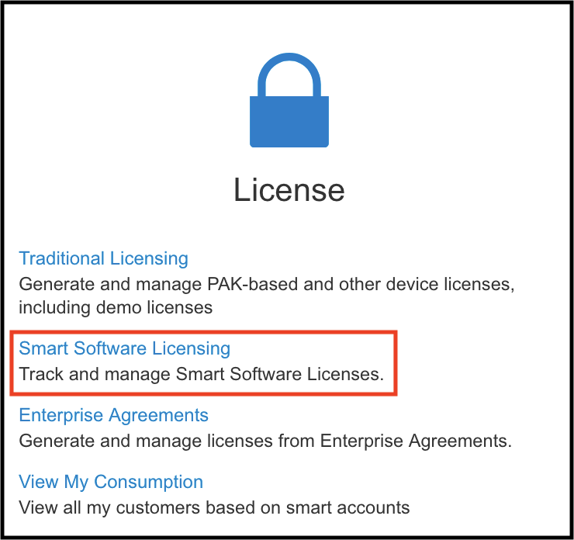

**Step 2:** In the top toolbar, click on the Inventory section and note that a Virtual Account will be selected by default. If you wish to navigate to a different Virtual Account, then click on the current one's name. A dropdown menu will appear, which will enable you to select the desired Virtual Account.

*In this example, I have selected the virtual account "ether-lab”.*

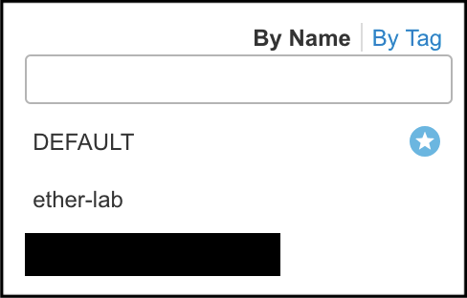

**Step 3:** Verify that you have an adequate amount of licenses in your Virtual Account inventory before clicking License Reservation...

**Step 4:** The Smart License Reservation screen will appear, which will require a reservation request code to be entered.

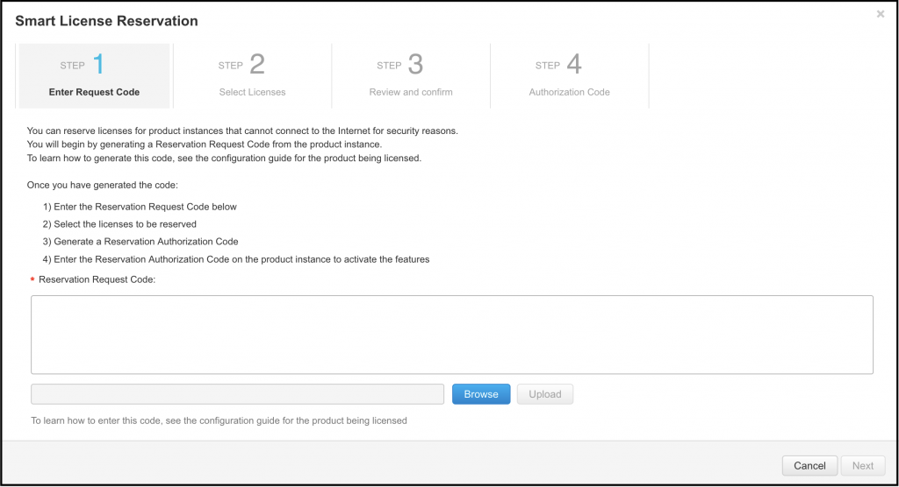

**Step 5:** Log in to the Cisco device that you wish to license, enter privileged mode, and then verify whether license reservations have been enabled with the command: show license reservation.

* If license reservation is **ENABLED** then skip to Step 7

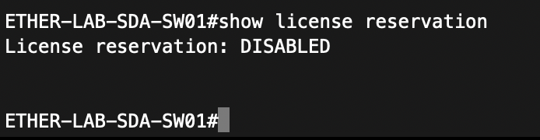

**Step 6:** If license reservation is **DISABLED**, then configure it by entering global configuration mode and entering the command license smart reservation. Verify it has been successfully enabled while in global configuration mode with the command do show license reservation, once confirmed drop back to privileged mode with the exit command.

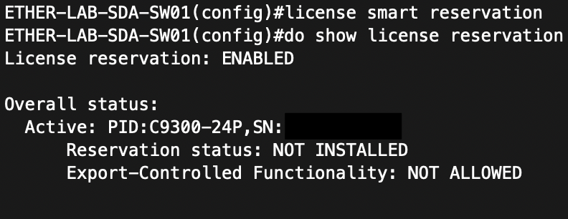

**Step 7:** Let's assess the options available for smart licensing:

* **all:** reservation request for ALL systems - unable to find information regarding what this is used for (to be updated)
* **local:** used to create a reservation request for the device you are currently logged onto
* **universal:** this option has been deprecated

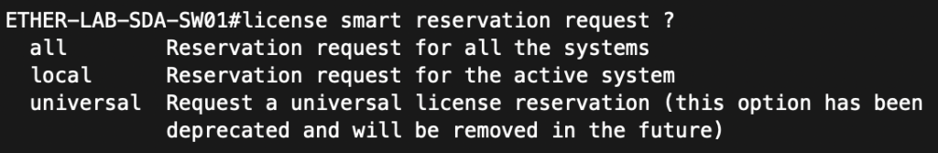

**Step 8:** Generate the reservation request code with the command license smart reservation request local.

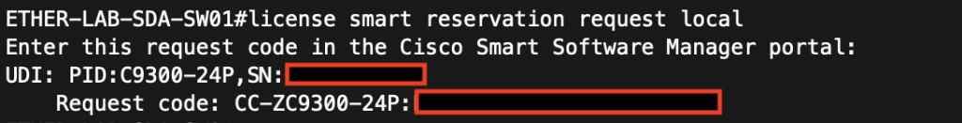

**Step 9:** Copy the request code from Step 8 into the Smart License Reservation form from Step 4 and then click Next.

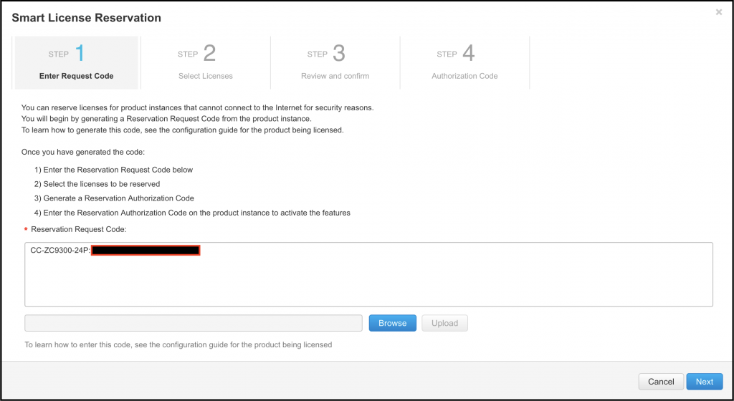

**Step 10:** Verify that the displayed device details are accurate before selecting Reserve a specific license.

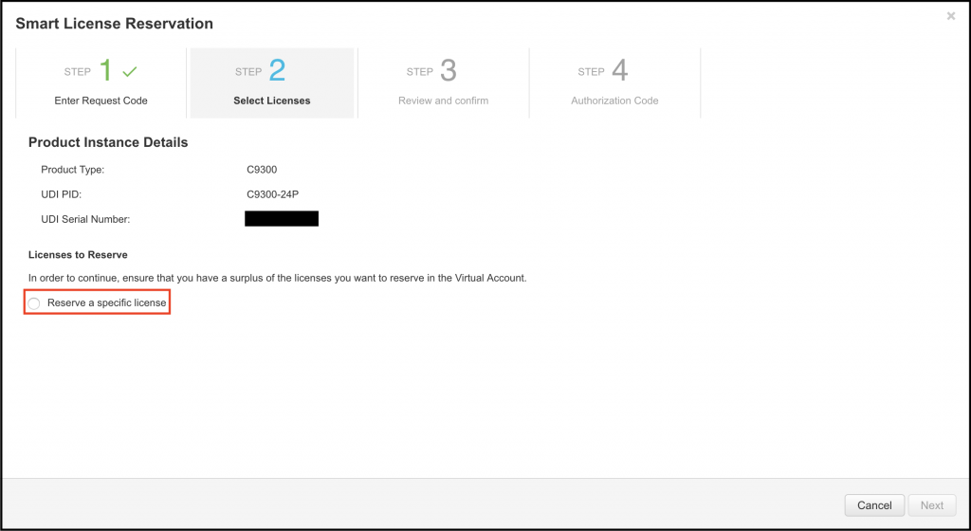

**Step 11:** Reserve the desired license(s) for the device and then click Next, review the licenses to reserve and then click "Generate Authorization Code".

* A warning prompt may appear on this page if the license SKU that you selected is partially fulfilled. An example of this would be a perpetual license (C9300 24P Network Advantage) has been delivered into the virtual account, but the related subscription license (C9300 24P DNA Advantage) has not. In this scenario, **DO NOT** proceed with the offline reservation process, as the perpetual license requires a subscription license to be present with the authorization code upon first activation. I have seen specific export control functionality (e.g., cryptographic functionality) fail to initialise if you "rush" the licensing process

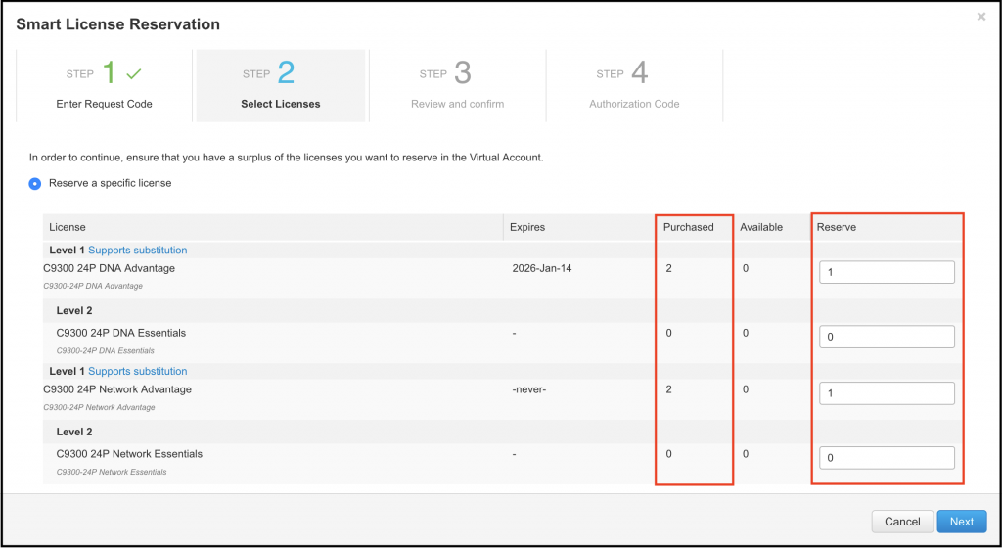

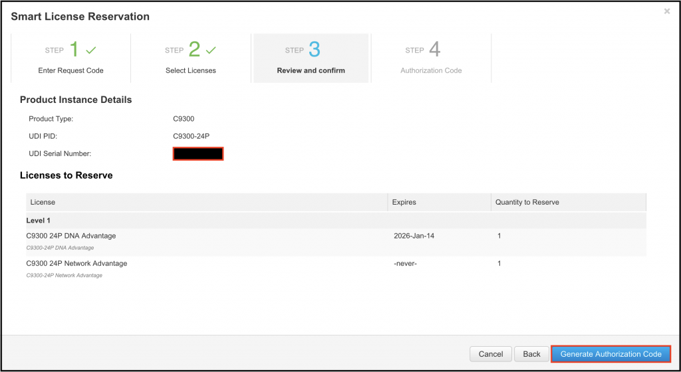

**Step 12:** An authorization code will be generated with the entitlements selected in Step 11, click the Download as File option.

* You can click Copy to Clipboard, but I have encountered instances where pasting the output to CLI may not work due to CLI character limitations. If you want to proceed with this option, I recommend creating a file on the device's flash from the copied text and referencing it in Step 14.

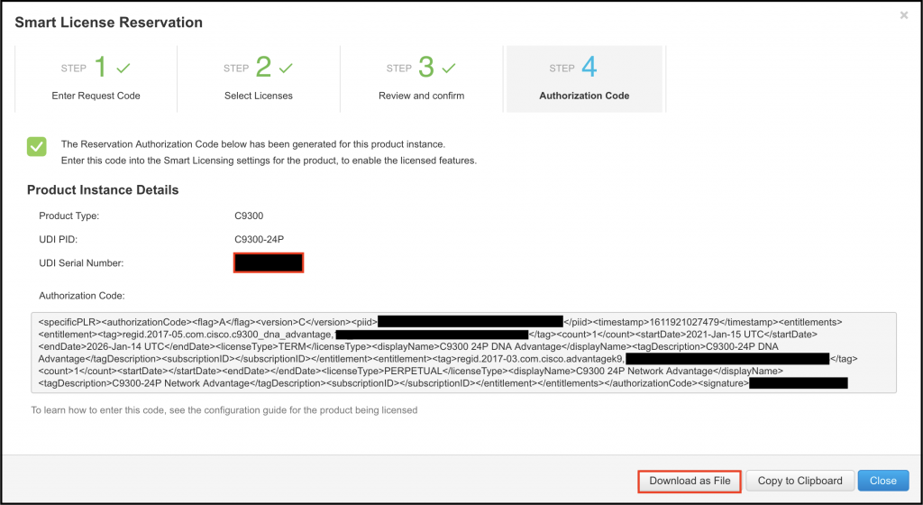

**Step 13:** Copy the downloaded file to the Cisco networking device. In this example, I use a physical USB as a means of transport. However, you could also use file transfer protocols (e.g., TFTP, FTP, etc...) in its place.

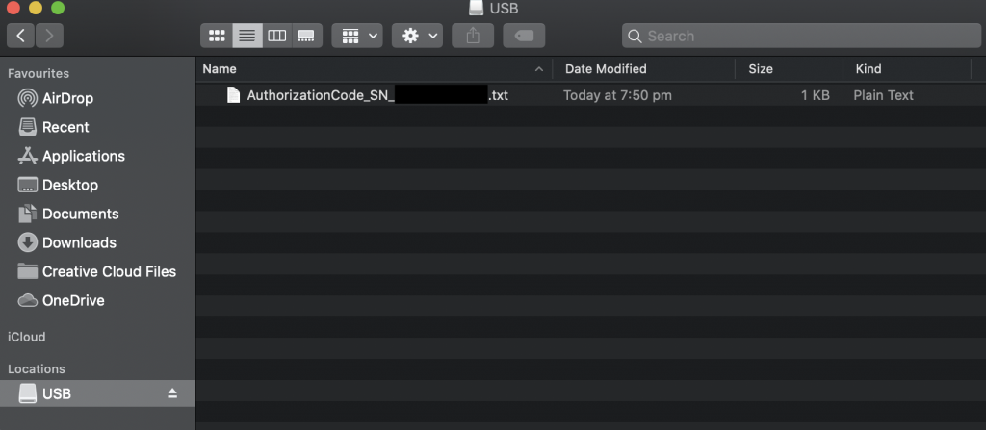



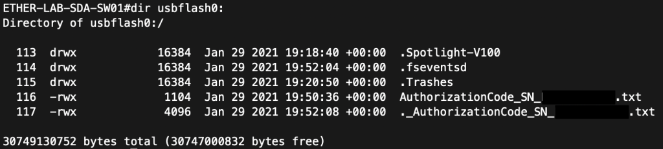

**Step 14:** Install the copied file with the command license smart reservation install file <DIRECTORY>:<file_name>".

* In this example, the command used was license smart reservation install file usb0:AuthorizationCode_SN_XXXXXXXX.txt.
* **If the process fails, then verify that the file you copied contained the EXACT information output in Step 12 before re-attempting Step 14.**

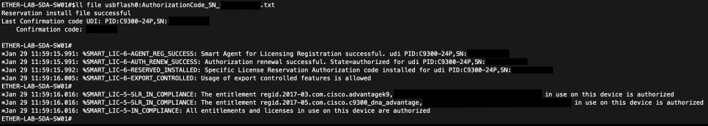

**Step 15:** Verify that the license(s) have been installed with the show license summary command.

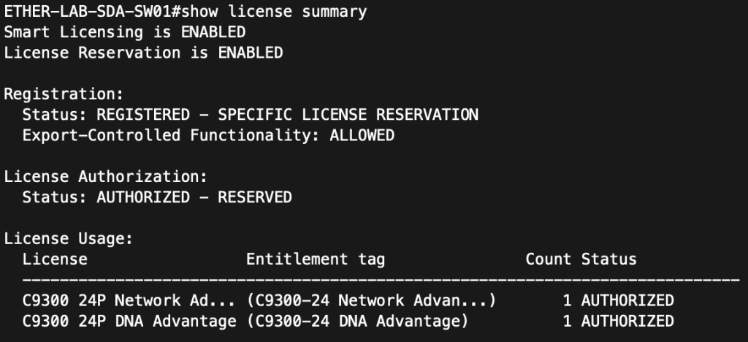

# Updating a Smart License Reservation

**Section Purpose:** Outlines how to update an existing license reservation.

**When Would You Do This:** If you purchased an additional license or subscription post-installation, for example, if you were migrating switches from Network Essentials to Network Advantage licenses.

**Step 1:** Access the Smart Software Licensing portal and navigate to the Virtual Account that the device(s) licenses reside in. Click on the tab Product Instances, click the button Actions, and then click Update Reserved Licenses....

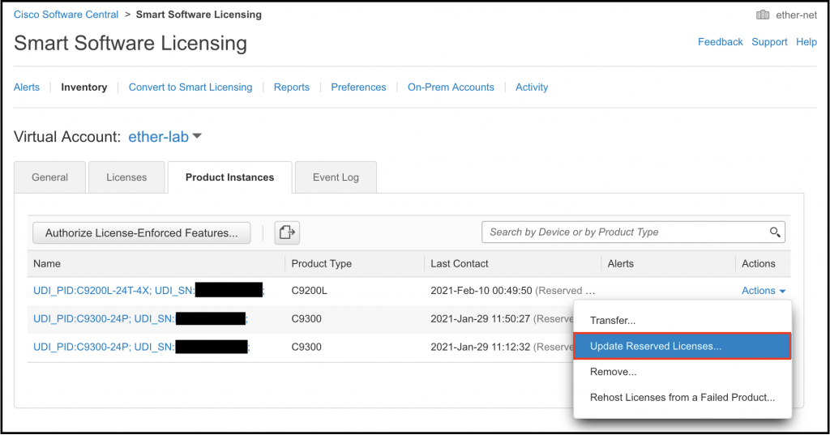

**Step 2:** Verify that the license you wish to reserve is available for reservation and then click Next.

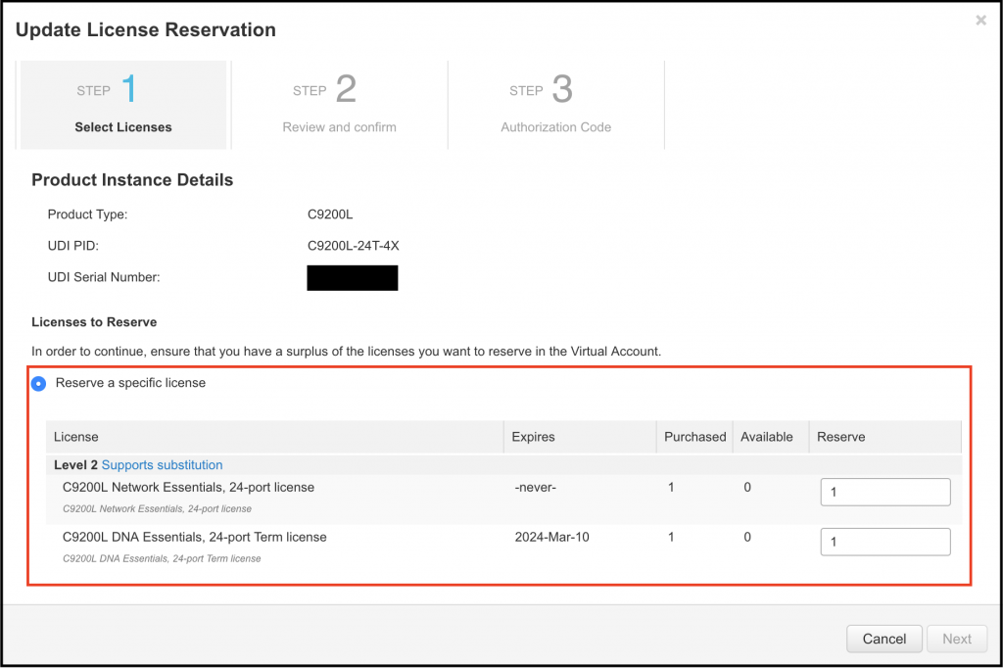

**Step 3:** A review and confirm prompt will appear on the next page, highlighting the licenses you are reserving. If the information is valid, then click Generate Authorization Code.

**Step 4:** Copy the authorization code to the device and then install it - for specific details refer to Reserving a New Smart License Steps 13 to 15.

# Returning a Reserved Smart License

**Section Purpose:** Outlines how to return an already reserved smart license to a Virtual Account license inventory.

**When Would You Do This:** Decommissioning or repurposing equipment

**Step 1:** Log in to the Cisco device that you wish to decommission/repurpose and then enter the command license smart reservation return local. A confirmation prompt will appear - enter yes to continue. **ONCE YOU ENTER "YES" THE DEVICE WILL BECOME UNLICENSED AND WILL LOSE LICENSED FUNCTIONALITY.**  A reservation return code will be generated for you to use in the next step.

**STOP:** Do not perform this command on equipment that is still in production as it can be highly disruptive depending on the features you are revoking licenses for. If you are uncertain about how to proceed with planning the decommissioning of networking equipment, then contact your Cisco Partner or raise a Cisco TAC case for advice and assistance.

**WARNING:** Additional caution should be exercised if working with stackable technologies lest you accidentally unlicensed the entire stack!

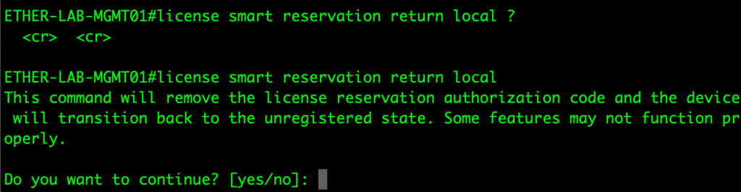

**Step 2:** Access the Smart Software Licensing portal and navigate to the Virtual Account that the device(s) licenses reside in. Click on the tab Product Instances, click the button "Actions", and then click Remove...

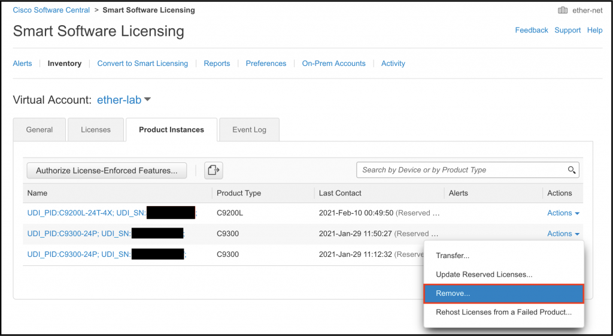

**Step 3:** Enter the reservation return code from Step 1 and then click Remove Product Instance. The reserved license will be deallocated and returned to your device inventory.

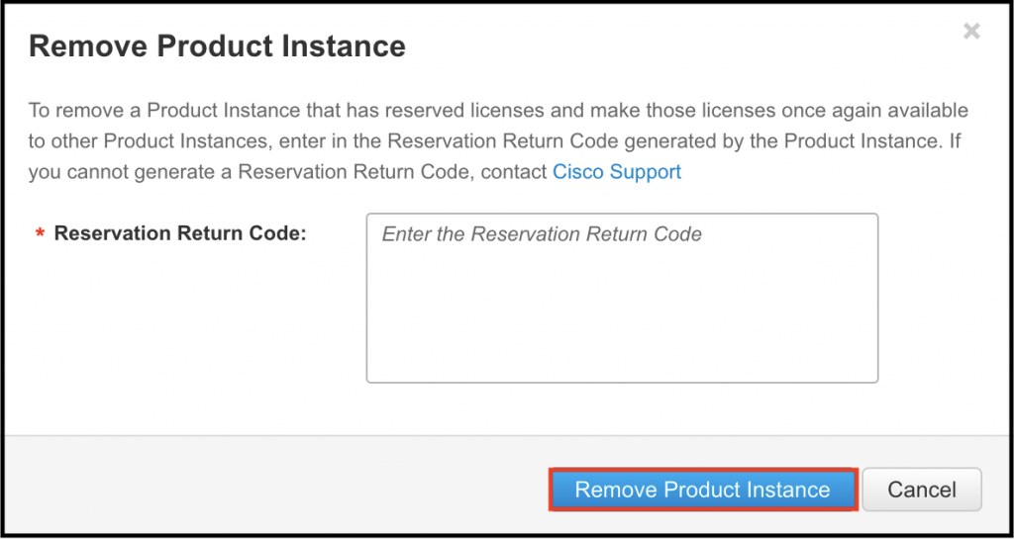

# Rehosting a License from a Failed Product

**Section Pre-Requisites:**

* You must have a valid RMA case lodged with Cisco Support to utilise this feature.

**Section Purpose:** Outlines how to take a license from a physically failed device that cannot have its license(s) revoked.

**When Would You Do This:** Typically, during your organisation's incident management process.

**Step 1:** Access the Smart Software Licensing portal and navigate to the Virtual Account that the device(s) licenses reside in. Click on the tab Product Instances, click the button Actions, and then click Rehost Licenses from a Failed Product...

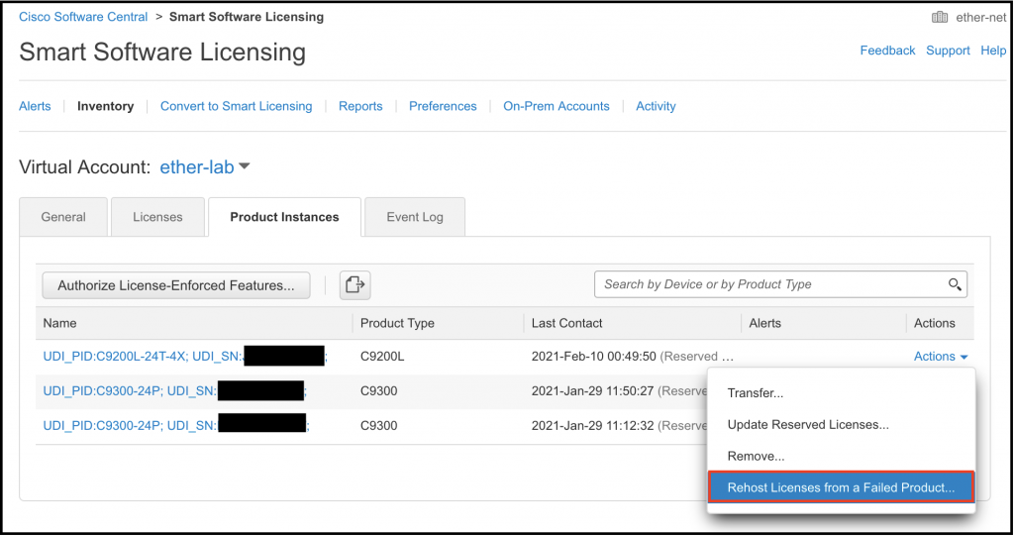

**Step 2:** Review the defective product's detail before logging in to the Cisco device that will be replacing it. Obtain the reservation request code from the replacement product - refer to the section Reserving a New Smart License Steps 5 to 8 if you need assistance with this process.

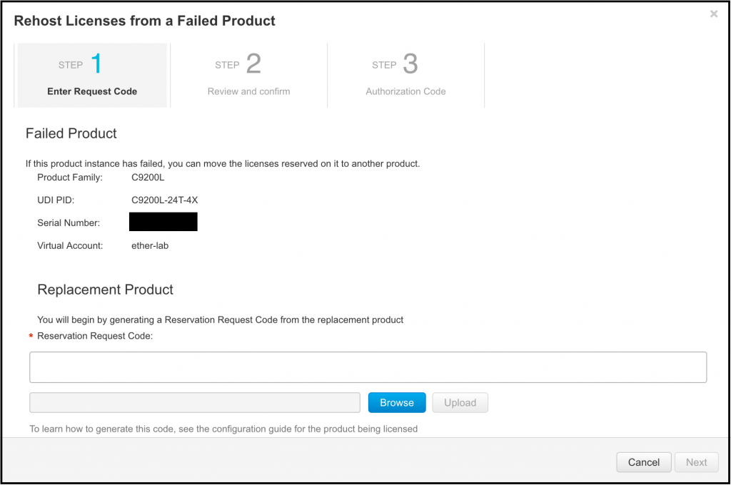

**Step 3:** Scroll down the page and complete the notes section. At a minimum, this should include your RMA/warranty claim Support Manager Case used to manage the return of the defective product. Once completed, click "Next".

If you do not include the RMA number, you will experience license compliance issues. Also, ensure that you update Cisco Support on the RMA return process progress to avoid incurring additional expenses associated with the failure to return defective products. **You can and will get billed if you abuse this process!**

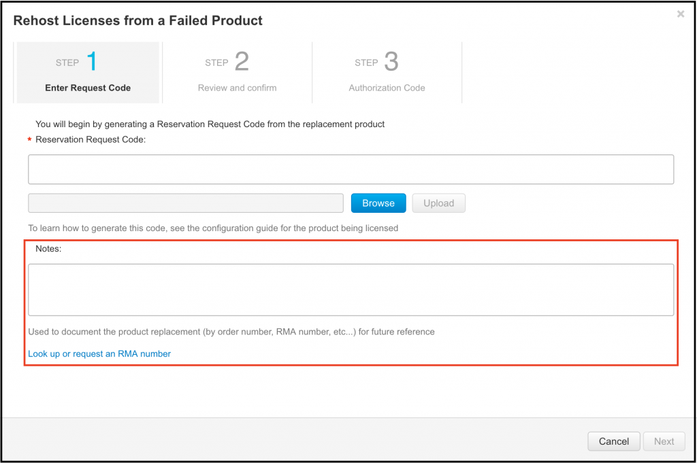

**Step 4:** Review that all displayed information is correct before clicking "Generate Authorization Code".

**Step 5:** Copy the authorization code to the device and then install it - for specific details refer to "Reserving a New Smart License" Steps 13 to 15.

# Online References

Cisco  
[Specific License Reservation](https://www.cisco.com/c/en/us/td/docs/switches/lan/catalyst_slr/b-169-9000-series-SLR-cg/b-169-9000-series-SLR-cg_chapter_00.html#concept_fqh_vzk_rlb)

Cisco  
[Smart Licensing Guide for Access and Edge Routers](https://www.cisco.com/c/en/us/td/docs/ios-xml/ios/smart-licensing/qsg/b_Smart_Licensing_QuickStart/b_Smart_Licensing_QuickStart_chapter_01000.html)

Cisco  
[Rehost Licenses from a Failed Product](https://software.cisco.com/web/fw/softwareworkspace/smartlicensing/ssmcompiledhelps/c_rehost_license_from_failed_product.html)

Cisco  
[Smart Licensing Troubleshooting Steps and Considerations on Catalyst platforms](https://www.cisco.com/c/en/us/support/docs/switches/catalyst-9500-series-switches/214484-cisco-smart-licensing-troubleshooting.html#anc3)